### **Holly Wreath Torus**

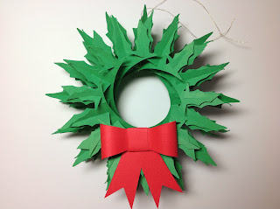

Holly Wreath Torus

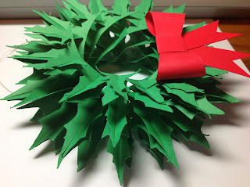

Side view of the torus...notice the swirling pattern...lovely!

I love the torus shape. It is a sliceform that swirls around and is fascinating to look at. I modified my original torus and created this holly wreath design. This torus shape has been discovered by a fellow papercrafter, Carol at <http://extremecards.blogspot.com/2013/11/preview-holly-wreath.html> from my blog. She created a leaf torus and then created a holly wreath torus. She posted her holly wreath torus a few weeks ago. I think her holly leaf design is a little bit more shapely than mine but the holly leaf shape is still the same...great minds think alike! Please note...I did not copy her. I have had this design for quite a while and I just didn't have the time to publish it...too many designs and not enough time as my sleep can attest to.

The bow is not the same exact size as the one in the photograph and there is one extra ribbon...I decided I wanted a little more intricate design for the Bow ornament. The Silhouette software had an error and the original design was lost in restarting the program...back to square one. Oh well..lessoned learned...always save your design...software errors abound! However, something good came out of it, I created another ornament which I would not have done originally.  
 To make the holly leaf torus, there are two pages of toruses. One page has the slit on top and the other has the slit on the bottom. Always start in the middle and end in the middle. It makes everything easier. Be very slow and methodical when doing this torus. The points of the holly like to get stuck to one another but everything works nicely if you are patient. If you ever get frustrated, just walk away and take a breather. It will be very satisfying when it is completed. The directions for the torus are on a previous post. <http://papercraftetc.blogspot.com/2013/10/a-honeycomb-pumpkin-decoration-for-fall.html>

To make the bow. Curl the bow tie piece into an oval as shown below.

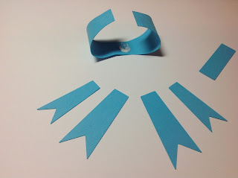

Put a dab of glue under the bow tie.

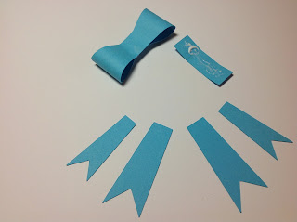

Put glue on the rectangular piece which wraps around the bow tie.

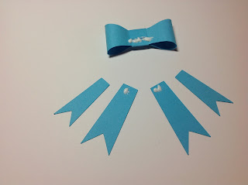

Put glue on the bow tie and ribbon pieces and attach to the back of the bow.

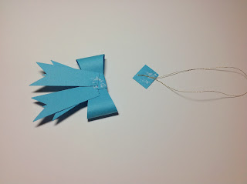

I added a square piece of paper to the hangar (not given...just cut a little square with scissors) to give the bow more strength as an bow ornament. This does not need to be done if you are making the holly wreath torus.

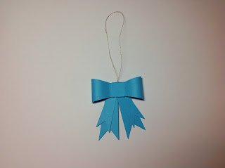

Bow Ornament

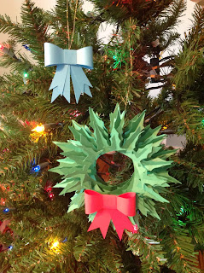

I added a string to the Holly wreath so that I could hang it on the Christmas tree.

Merry Christmas!